#MyWaysToWellbeing Social Media Toolkit
Thank you for supporting The Kite Trust’s #MyWaysToWellbeing campaign which aims to raise awareness of the ways in which we can all contribute to supporting the mental health and wellbeing of LGBTQ+ young people across Cambridgeshire and Peterborough. We’d love for you to use some of the content below to create posts on your own social media channels – feel free to get creative if you want to create your own visuals, just be sure to include the tags #MyWaysToWellbeing and @TheKiteTrust!
Right click on the graphics below and select ‘save as picture’ to use them.

Timing | Graphics | Suggested Text
Anytime between Sunday 14th May and Saturday 20th May | 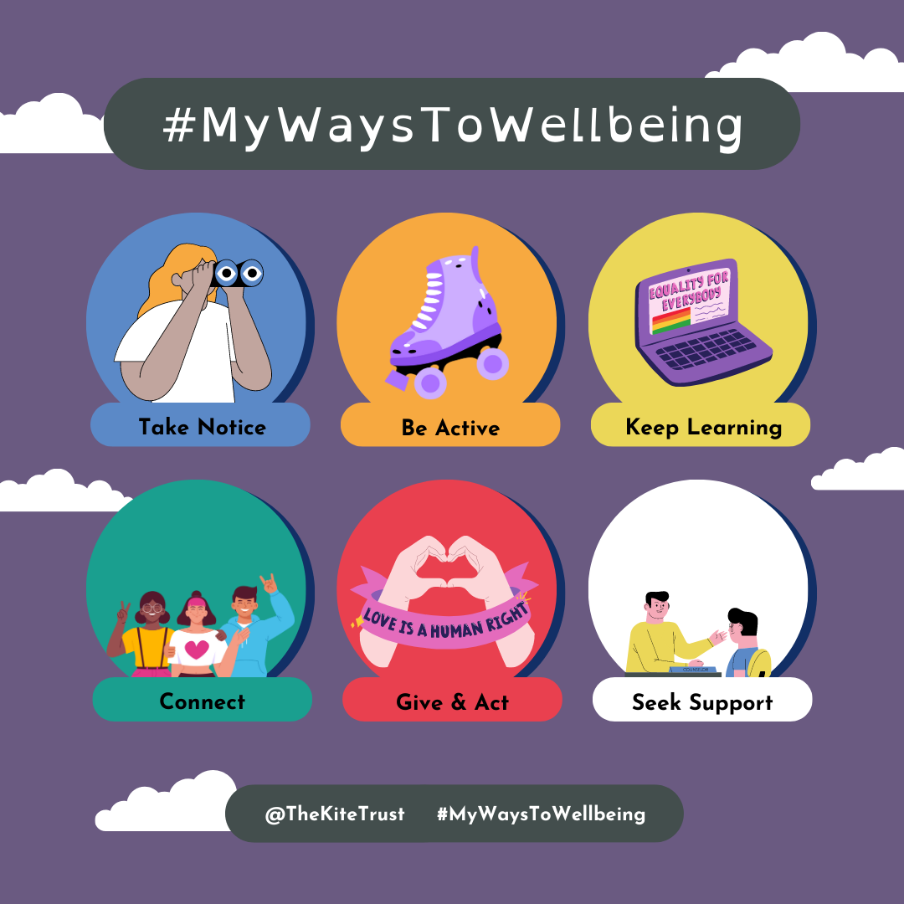  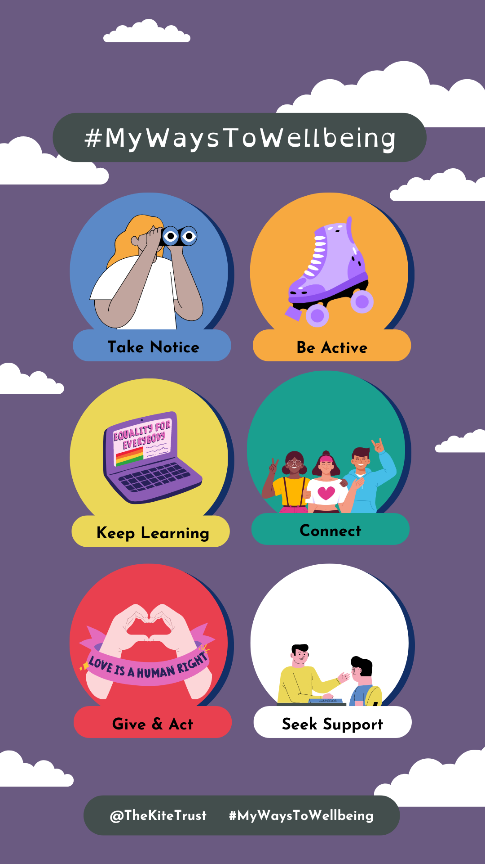 | We’re supporting @TheKiteTrust and sharing #MyWaysToWellbeing to mark #MentalHealthAwarenessWeek! Find out more about the campaign and join in at: www.thekitetrust.org.uk/wellbeing  [Use this graphic as an initial image and follow with photos/captions of relevant wellbeing activities that your organization wants to promote – bonus points if they highlight LGBTQ+ inclusion!]
Anytime between Sunday 14th May and Saturday 20th May | 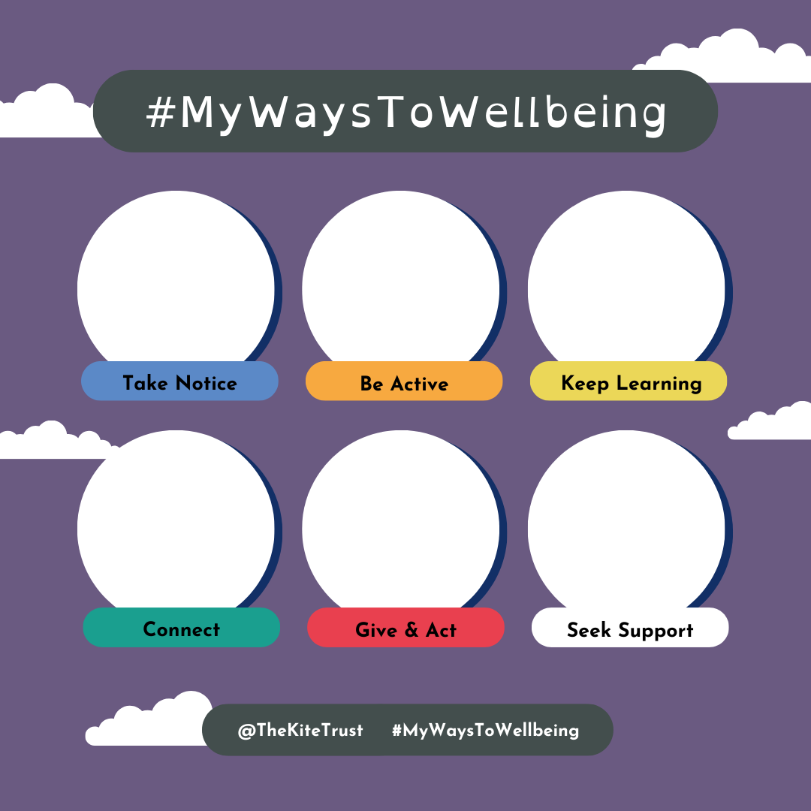  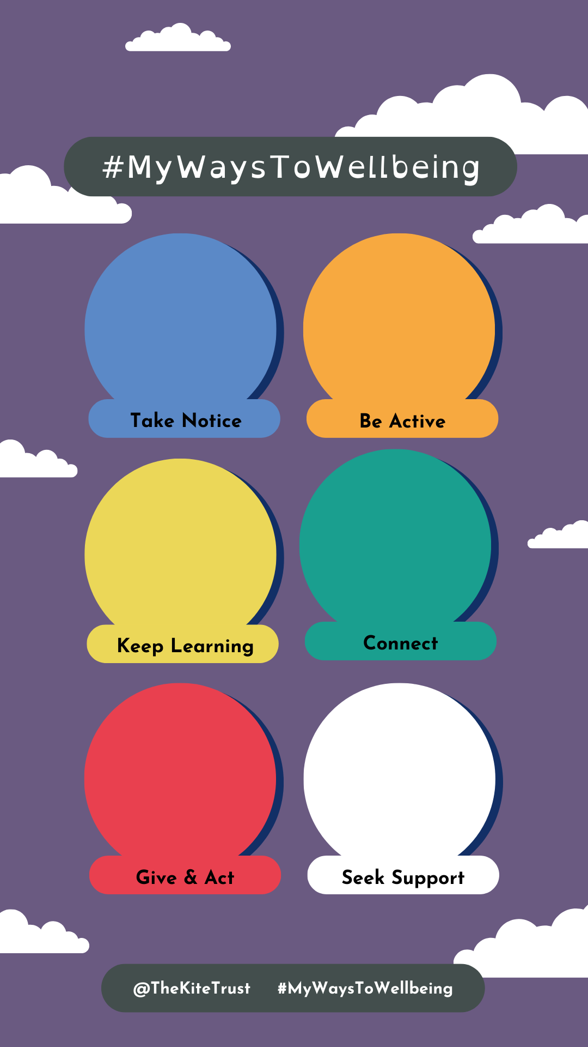 | [Suggested text as above – this format can be personalized with stickers in each of the bubbles]

